Python Lab Report – File & Dictionary Operations
Student Name: Pooja Sattigeri
Date: 27-09-2025
Course: Python Programming Lab

Task 1: Grade Checker
Explanation
- Purpose: To take a numeric score as input and determine the grade.
- Logic:
  - If score ≥ 90 → "A"
  - If 80 ≤ score < 90 → "B"
  - If 70 ≤ score < 80 → "C"
  - If 60 ≤ score < 70 → "D"
  - Below 60 → "F"
- Implementation: Uses basic if-elif-else statements to check the ranges.
- Input: Numeric score (integer)85.
- Output: B (Grade printed to the terminal).
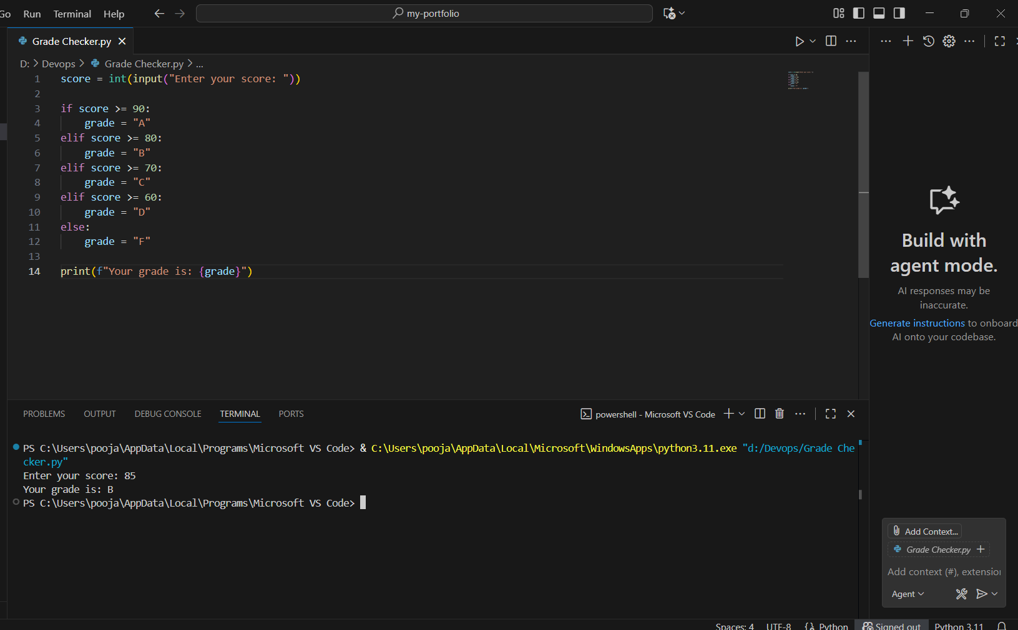
Task 2: Student Grades
Explanation
- Purpose: Manage student grades using a dictionary.
- Logic:
  - Store students as dictionary keys and grades as values.
  - Allow user to:
    - Add a new student & grade
    - Update existing student’s grade
    - Print all student grades
    - Exit program
- Implementation: Uses dictionary for storage and if-else statements to handle user actions.
- Input: User action (add, update, print, exit) and student name/grade.
- Output: Choose action: add/update/print/exit: print
Alice: A
Bob: B
Charlie: C
- Choose action: add/update/print/exit: add
Enter student name: David
Enter grade: B
David added with grade B.
- Choose action: add/update/print/exit: add
Enter student name: Alice
Enter grade: A+
Alice already exists.
- Choose action: add/update/print/exit: update
Enter student name to update: Bob
Enter new grade: A
Bob's grade updated to A
- Choose action: add/update/print/exit: print
Alice: A
Bob: A
Charlie: C
David: B
- Choose action: add/update/print/exit: exit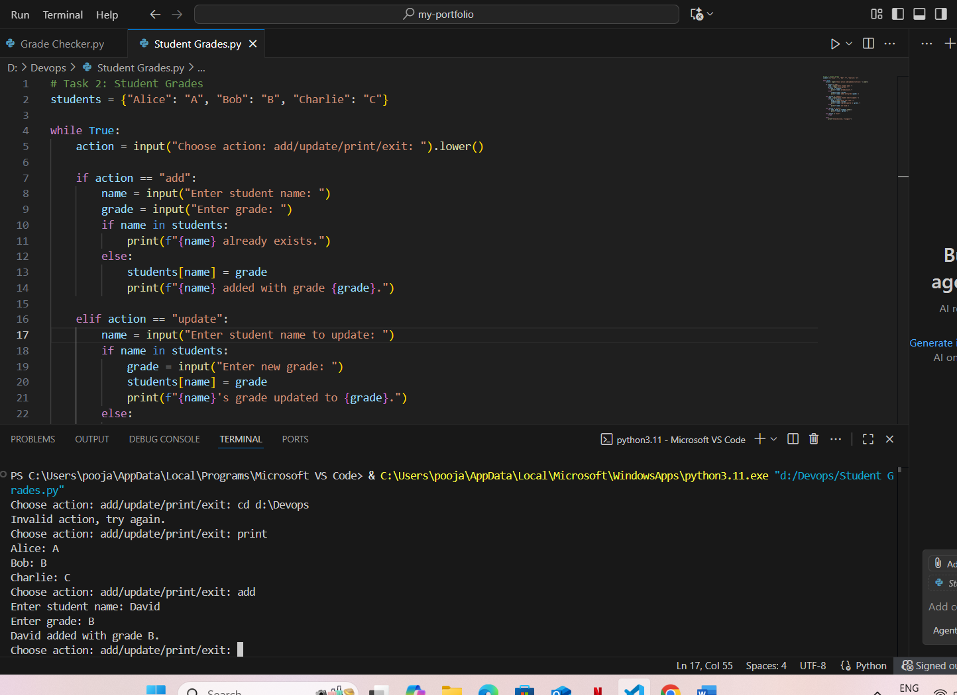
Task 3: Write to a File
Explanation
- Purpose: Create a text file and write content into it.
- Logic:
  - Use open() in write mode ("w") to create the file.
  - Use file.write() to add content.
  - with ensures file is automatically closed.
- Output: Confirmation message and a new file (example.txt) containing the written content.
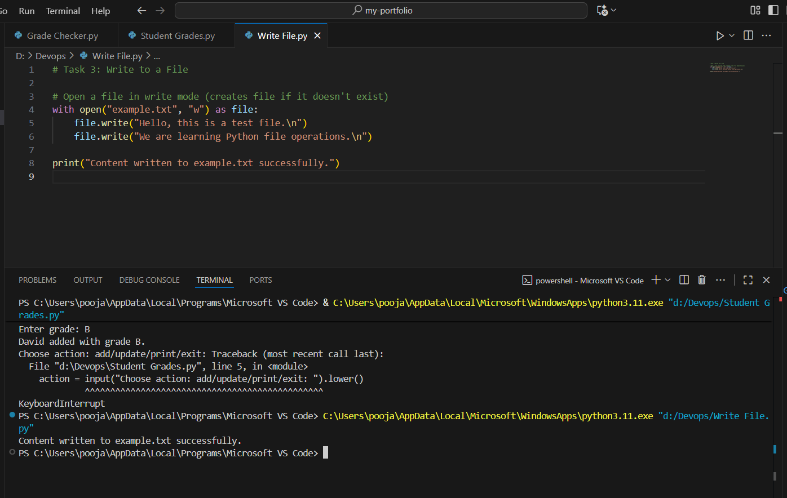

Task 4: Read from a File
Explanation
- Purpose: Read and display content from a file.
- Logic:
  - Use open() in read mode ("r").
  - Use file.read() to read entire content.
  - Print content to the terminal.
  - Input: No input needed.
  - Output: Shows the text from the file in the terminal.
